Name: __________________________________________ Date: ________________________
Solving Equations with Variables on Both Sides (10 questions)
Solve each equation. Show your work. Circle your final answer. The answers are in the box. If your answer is not in the box, that means you did something wrong.

- $14x – 8 = 22 + 20x$
- $x + 81 = 9x – 7$
- $39 – 12x = 7 – 16x$
- $-15x – 40 = 23 – 8x$
- $63 – x = 2x + 3$
- $3x + 46 = 1 + 18x$
- $12x – 18 = 13x + 18$
- $–x – 1 = x - 21$

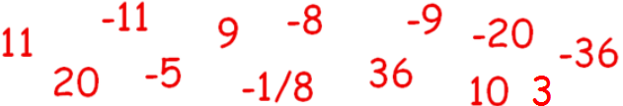
Solve for x then find the measure of the angles.

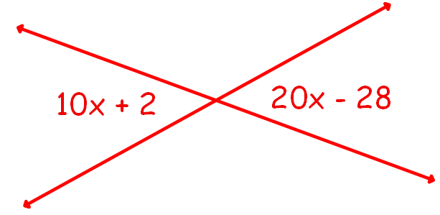
- Find x.

- What is the measure of each angle?

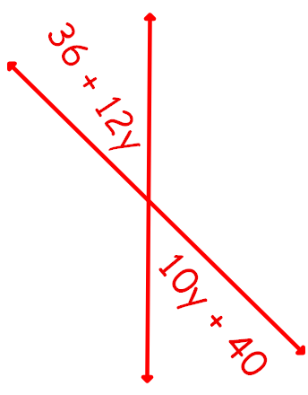
- Find y.

- What is the measure of each angle?

