EOC Review Packet A
DUE AT THE END OF THE BLOCK!
- Solving Equations
    - Multiplication/Division Problems
Example: $-4x=10$

Example: $4=\frac{x}{3}$

  - 2 Step
Do the addition or subtraction FIRST!
Example: $\frac{2}{3}x-5=10$

Example: $5=10-2x$

  - Distributive Property
First, distribute the term against the parentheses!
Example: $-3\left(-x+4\right)=21$

  - Entire Side Divided by a Number
Get the number off the bottom first!
Example: $\frac{2x-4}{3}= -4$

- Writing Basic Functions
Example: Your cell phone costs $20 a month as well as 10 cents a minute. Write a function to calculate your monthly bill if you talk for x minutes.

Example: A plane is at an altitude of 5,000 feet and is descending 300 feet each minute. Write a function to calculate the altitude of the plane.

  - Percentages
Must divide percent by 100 to get decimal form before you can use it to do math problems!
The variable ALWAYS gets multiplied by the percent!
Example: Tom earns $200 a week plus a 15% commission. Write a function to represent his earning if he sells x dollars worth of goods.

- Exponential (Make sure you really understand these 4 multiple choice!)
Exponential Function Formula: Formula involving percent change:
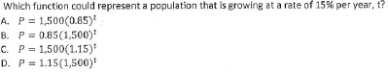
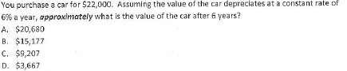
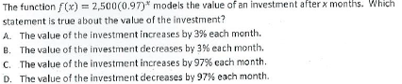
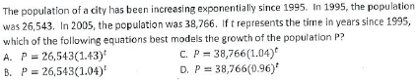
- Graphing and Identifying Points on a Coordinate Plane
Remember, points are made of an x coordinate, then a y coordinate. (x,y)

Example: Graph the following points:
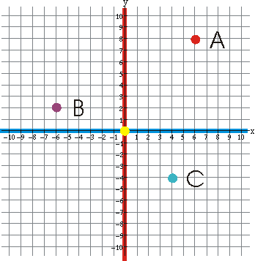
A(4,7) B(-2,4) C(5,-6) D(-8,-6) E(4,0) F(0,-3) 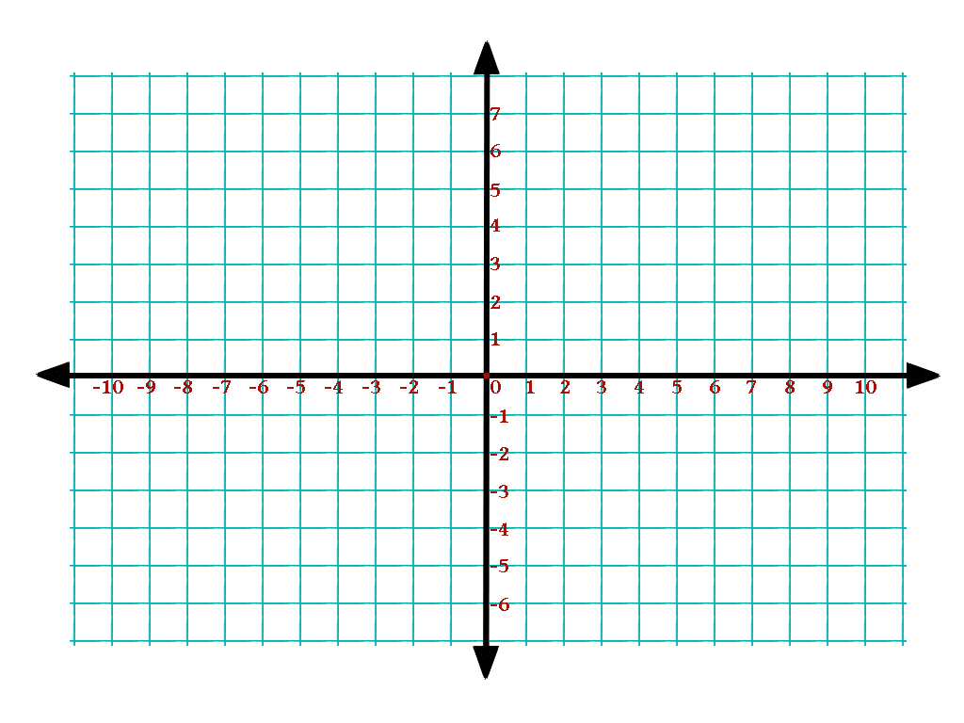

Example: Identify the points from the graph.

- Distance Formula
Might say find the distance, length of a line, how far apart two places are
Formula:
___________________________
Must remember to put second parentheses in the calculator!

Example: Find the length of the line below:
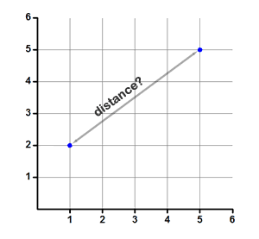

- Midpoint Formula
  - Finding Midpoint from 2 Endpoints
Might say find midpoint, halfway between 2 points, center of a line
Formula:
_______________________

Example: Scott lives at (-4, 3) and Joe lives at (5, 9). If they want to meet half way between their houses, where should they meet?

  - Finding an Endpoint when Given the Midpoint
Use midpoint formula setting it equal to the midpoint that is provided. Solve the equation for the missing endpoint! Do this first using just the x’s and then again using just the y’s!

Example: The midpoint of Line AB is (-3,6) If point A is at (-10,12), what is the other endpoint, B?

- Polynomials
  - Standard Form, Degree, Terms
How do you write a polynomial in standard form?

Example: Write in standard form: $x^{2}-{2x}^{3}+3-5x$

  - Adding
Combine Like Terms. Leave the Exponents Alone!!!
Example: $\left(2x^{2}+5x-7\right)+ (3x^{2}+6x-8)$

Example: $\left(5x^{2}-3x+2\right)+ (x^{2}+3x-5)$

Example: $\left(4x^{3}-2x+2\right)+ (3x^{2}+5x-8)$

    - Perimeter Problems
Perimeter means to __________________________________

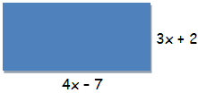
Example: Find the perimeter of the shape:

  - Subtracting
First, Distribute the Negative into the Parentheses!
Example: $\left(2x^{2}-4x+15\right)-(3x^{2}+2x-5)$

Example: $\left(2x+5\right)-\left(-4x+3\right)+\left(5x-8\right)$

  - Multiplying
Multiply Coefficients, ________ Exponents.
    - Monomial * Polynomial
Example: $4x^{3}\left(2x^{2}+3x-5\right)$

Example: $-2x^{3}y(4x^{4}y^{2}-xy^{2}+3y^{4})$

    - Binomial * Binomial
Distribute the terms on the left to EVERY term on the right!
Example: $\left(x+7\right)(x-4)$

Example: $\left(2x-4\right)\left(5x+8\right)$

Example: $\left(2x-5\right)(2x+5)$

Example: ${(2x+4)}^{2}$
Must rewrite as:

    - Binomial * Trinomial
Example: $\left(x-6\right)(2x^{2}+5x-10)$

    - Area Problems
Formula for Area of a Rectangle:

Formula for Area of a Triangle:

Example: Find the area of the shape:

Example: Find the area of the shape:
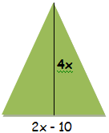

  - Dividing
When dividing coefficients, ____________ exponents.

Example: $\frac{27x^{8}y^{6}-18x^{5}y^{5}+36x^{7}y^{3}}{9x^{4}y^{3}}$

  - GCF
Find the biggest number that can divide each term.
Then find the largest number of each variable you could remove from each term.
Example: Find the GCF: $4x^{5}y^{5}+12x^{3}y-20x^{2}y^{3}$

Example: Find the GCF: $15x^{4}y^{3}-27x^{3}y^{6}+12x^{5}$

    - Factor by GCF
First, Find the GCF. Then, Divide the original problem by the GCF.
Write the answer as GCF(Quotient)

Example: Factor by GCF: $39x^{3}y^{2}z+13x^{4}yz^{2}-26x^{2}y^{5}z^{3}$
- Exponents
  - When Adding/Subtracting Coefficients
LEAVE Exponents Alone! Combine Like Terms!
Example: 3x + 4x
  - When Multiplying Coefficients
Add the Exponents.
Example: $\left(-4x^{2}y\right)(3x^{2}y^{2})$

Example: ($x^{4}y^{3})(8x^{2})$

Example: $\left(-3x^{4}y\right)\left(2x^{2}y^{3}\right)(4x^{4})$

  - When Dividing Coefficients
Subtract the Exponents.
Example: $\frac{39x^{5}y^{2}}{13x^{4}y^{2}}$

Example: $\frac{-6x^{7}y^{4}}{9x^{3}yz}$

Example: $\frac{9x^{2}y^{3}}{3x^{4}y}$

Example: $\frac{10x^{-3}y^{4}}{30x^{2}y^{-2}}$
  - When Raising Coefficients to a Power
Multiply the Exponents.
Example: ${(-2x^{4}y^{2})}^{4}$

Example: ${(4x^{3}y^{4})}^{2}(-2x^{3})$

Example: ${\left(\frac{3x^{3}y}{2z^{4}}\right)}^{-3}$

  - Zero Exponents
Mark out any term with a zero exponent. (Anything with a Zero Exponent equal one, so it won’t affect the answer.)
Example: ${(2x^{3}y)}^{0}{(4x^{3}y)}^{2}$

  - Negative Exponents
MOVE the term to the opposite side of the fraction and rewrite the term with a positive exponent.
For whole fractions to a negative exponent, FLIP the fraction.
Example: $\frac{5x^{-3}y^{0}z^{4}}{15m^{4}n^{-2}}$

Example: ${\left(\frac{2x^{4}y}{z^{2}}\right)}^{-1}$

Complete the chart:
Coefficients (Plain Numbers) | Exponents
Add/Subtract
Multiply
Divide
Raise to a Power
Zero Exponent Means:
Negative Exponent Means:

- Quadratics
  - Factoring
You must find 2 numbers that when you multiply give you the last term and when you add them give you the center term.
Last sign positive: Use 2 positives to add to a positive center OR
Use 2 negatives to add to a negative center
Last sign negative: Must use a positive and a negative.
The middle term has the same sign as the larger number.
Example: Factor $x^{2}+11x+18$
Example: Factor $x^{2}-15x+50$
Example: Factor $2x^{2}+8x-24$
Example: Factor ${-3x}^{2}+3x+168$
  - Vertex, Min/Max
Found using the Calculator. Enter the function on the Y= screen. Zoom until you can see the full parabola. Press 2nd Trace and choose either Minimum or Maximum. The vertex is the full point (x,y) and the min or max is just the y-value. (how high or low it goes on the y axis)

Example: For the equation $5x^{2}+10x+20$
Does it have a Minimum or Maximum:

Value of Min or Max:

Vertex:

- Evaluating
Substitute the given values for the corresponding exponent. (Plug them in.)
Example: Evaluate for the given vales: ${2a}^{2}+b^{3 } ;a=-2 and b=5$
Example: Evaluate for the given values: $\frac{c}{a} ; a=\frac{2}{3} and c=6$
Example: Evaluate for the given values: $\frac{x+y}{xy }; x=5 and y=7$
- Exponents
Example: ${\left(\frac{2x^{2}y}{4x^{4}y^{3}}\right)}^{-2}$

Example: ${\left(\frac{9x^{4}y^{2}}{x^{2}y^{3}}\right)}^{-2}$

- EOC Challenge Questions
  - Solving Equations
Example: Solve for x: $-\frac{3}{4}x-\frac{2}{3}=22$

Example: Samantha purchased a vehicle for $25,000. The value of the car depreciates $875 per year.
Write a function for the value of the car:
What is the value of the car after 4 years have passed?
  - Polynomials
Example: Find the area of the shaded region. (Takes 3 Steps!)
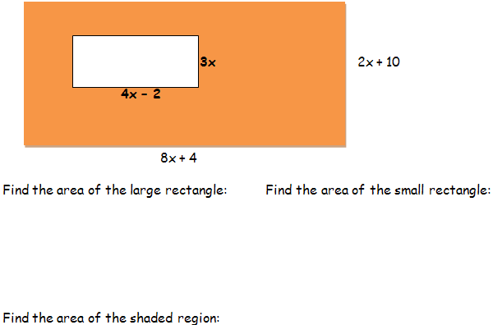

  - Distance
Find the perimeter of shape ABCD to the left.
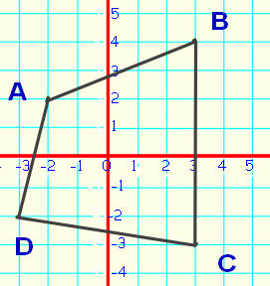
First, you must label the ____________.
Next, you have to use the ___________ formula 4 times to get the _____________ of each side.
Last, to get the perimeter you must ________ all the sides.
Now, Find the Perimeter:

1. A line has a slope of 3/5 and a y-intercept of 4. Write the equation of the line:
2. Write the equation of a line perpendicular to y=-3x+2 that goes through (-6,8)

3. Write the equation of a line parallel to y=1/2x+12 that goes through (12,2)

4. Find the slope of a line passing through the points (-2,1) and (5,-12)

9. What is the slope of the line x=-3?
Write the equation of each line below. Then tell the slope of each.
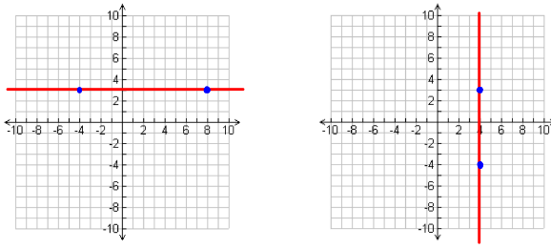
10. Equation: 12. Equation:
11. Slope: 13. Slope:
14. Graph 2x + 3y = 18 below: 15. Find the equation of the line below:
