Review: Linear Equations Name______________________________
1. A line has a slope of 3/5 and a y-intercept of 4. Write the equation of the line.

2. Write the equation of a line with a slope of -1/2 that goes through (6, -5)

3. Find the slope of a line passing through the points (-2,1) and (5,-12)

4. Write the equation of a line that passes through (2,6) and (4,-2)

5. Write the equation of a vertical line that goes through (-5,3).

6. Is this an uphill or downhill line: y = -2/3x + 5.

7. Where does the line y = 3x - 7 cross the y-axis?

8. Graph y = -2/3x + 3 9. Find the slope of the line below:
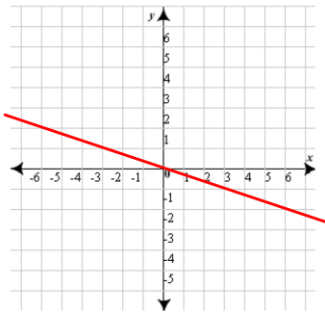
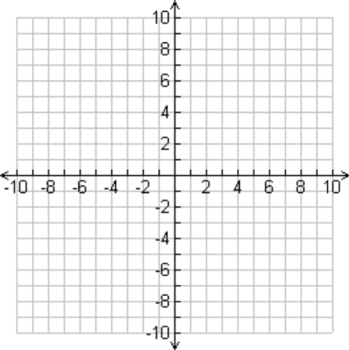
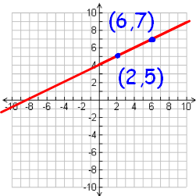
10. Write the equation of the line to the right:
  - Slope:
  - Y-intercept:
  - Equation of the line:

11. Graph the equation y=2x+5 12. Find the slope of the line below:
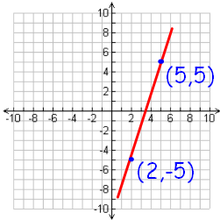
13. Graph the equation y=3 14. Graph the equation y=3x (tricky!)
15. Write 2x – 3y = 9 in slope intercept form. 16. Write -4x + 2y = 12 in slope intercept form.

17. What is the slope of the line x=-3? 18. Find the x & y intercepts: 3x + 2y = 12

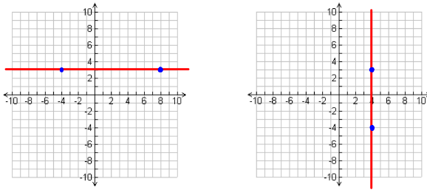
18. Equation: 20. Equation:
19. Slope: 21. Slope:

