Define each option on each problem below, , plots the points, then choose the correct answer:
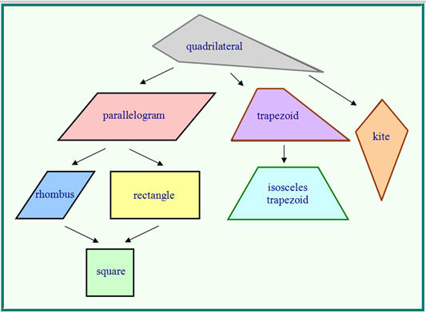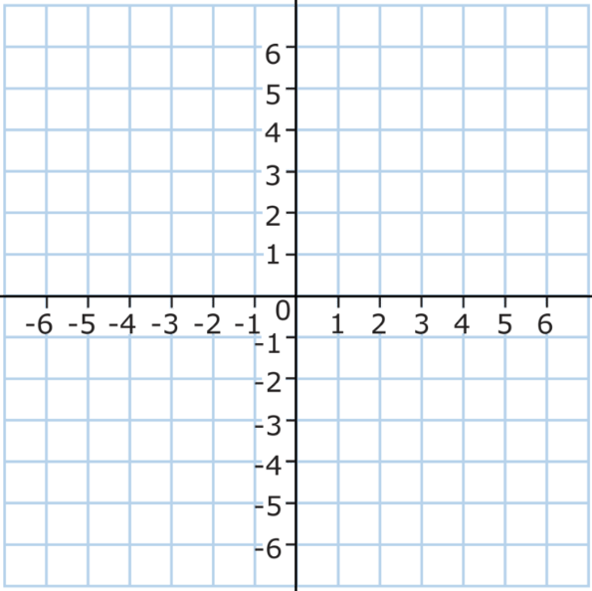
What is the most specific name for quadrilateral ABCD with vertices A(1,1), B(6,1),C(3,5), and D(-2,5)?
- Kite
- Parallelogram
- Quadrilateral
- Rhombus
- Square
- Rectangle
- Trapezoid
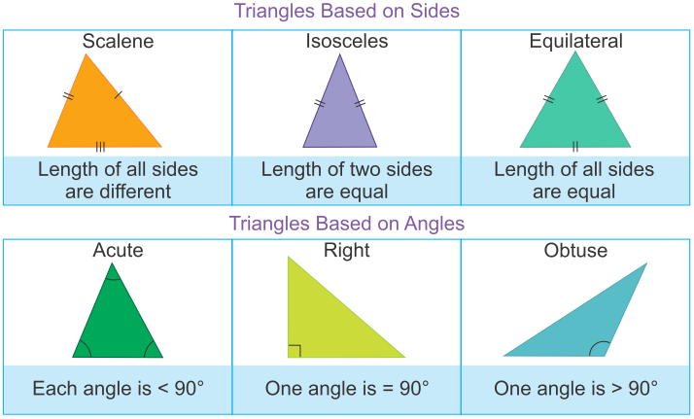
Triangle ABC has vertices located at the points A (1, -3), B (5, 0), and C (6, -4) on the coordinate plane. Which name best describes triangle ABC?
- Equilateral
- Isosceles
- Right
- Scalene
Math 1 Geometry Problems Review. GPE.4 Name_________________
The points A(-3, 3), B(0, 7), C(4, 10), D(1, 6) create parallelogram ABCD. What is the perimeter of parallelogram ABCD, in units? (I suggest you plot the points to help you!)
ANSWER: ______

Find the area of the triangle below:
ANSWER: __________
