**Name: ______________________________Date: __________________**

**Properties of a Parabola**

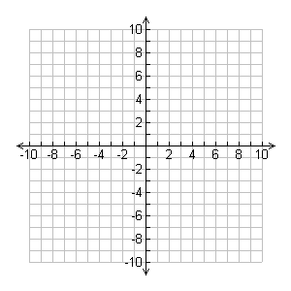**Identify the vertex, the AOS, y-intercept, and tell if it points up or down for each parabola. Then, use these 4 key features to graph each.**

|  |  |  |  |  |
| --- | --- | --- | --- | --- |
|  | **Vertex** | **Axis of Symmetry** | **Y-intercept** | **Points Up or Down** |
| $y=x^{2}-4x+1$ |  |  |  |  |
| $y=-x^{2}+2x+3$ |  |  |  |  |
| $y=2x^{2}+3x-5$ |  |  |  |  |
| $y=-{2x}^{2}+8x-2$ |  |  |  |  |
| $y=x^{2}-5$ |  |  |  |  |





1. .

Axis of symmetry: _____________________

Vertex: ________________________

Maximum or minimum? ________________

Domain where increasing? _______________

Axis of symmetry: _____________________

Vertex: ________________________

Maximum or minimum? ________________

Domain where increasing? _______________

1. What shape is formed when you graph a quadratic? ___________________
2. What does the sign of the “a” value tell you? Explain.

____________________________________________________________

____________________________________________________________

1. Tell which graph would be narrower:
   1. y = 2x2 + 3x – 4 or b. y = 4x2 – 2x + 7
2. Tell which graph would be higher:
   1. y = 2x2 – 2x + 2 or b. y = 3x2 - 2x + 9
3. Which quadratic would be increasing about the vertex?
   1. y = 2x2 + 3x – 4 or b. y = -4x2 – 2x + 7
4. Which quadratic would have a minimum?
   1. y = 2x2 + 3x – 4 or b. y = -4x2 – 2x + 7
5. How do you find the y-intercept of a quadratic equation?

_____________________________________________________________

1. What is the formula to find the vertex (or axis of symmetry) of a quadratic?
2. After finding the x-value for the vertex, how would you find the y-value?