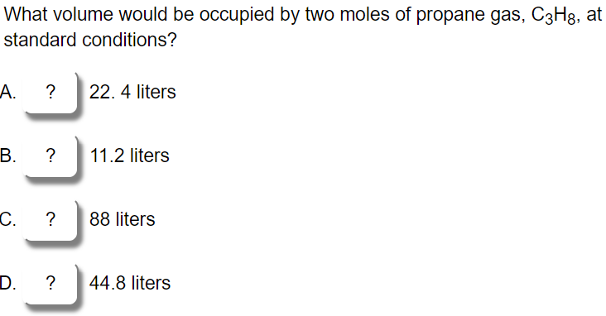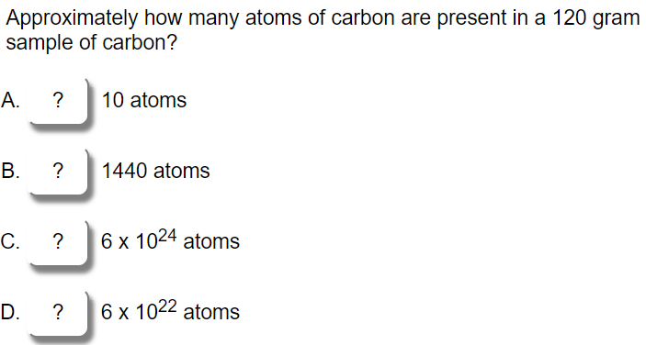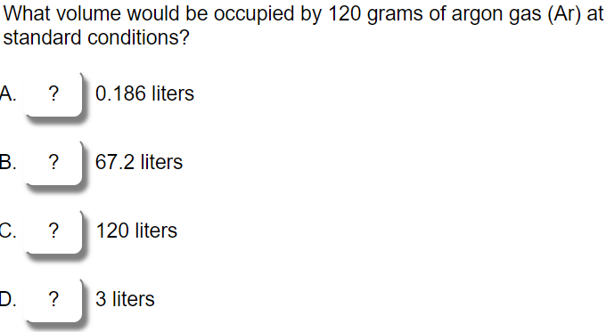
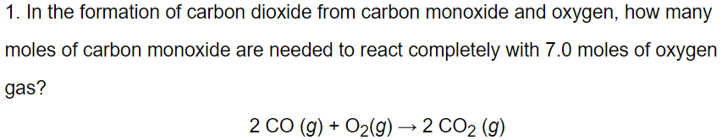

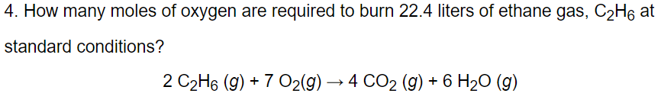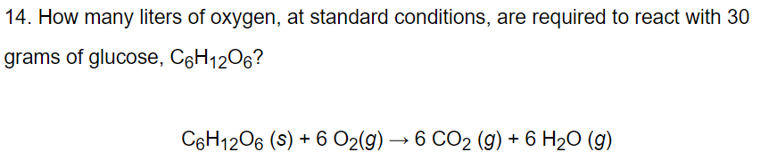
Balance:

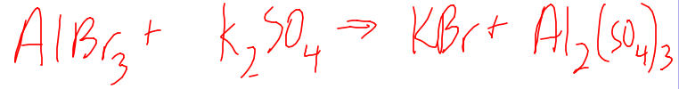

Write the chemical formula for each:

Aluminum Nitrate

Strontium Phosphate

Barium Hydroxide

Barium Carbonate

Ammonium Bromide

Sulfur Hexafluoride

