**Goal 5.03**

List the 4 indicators of a chemical change.

1.

2.

3.

4.

Explain how a burning splint can be used to test for hydrogen, oxygen, and carbon dioxide.

Lime water turns milky white and forms a precipitate when exposed to a gas. What is the identity of the gas?

Explain how color change could be a chemical or physical change.

Identify the following as a chemical or physical change:

1. Melting Ice
2. Burning Paper
3. Rusting
4. Decomposing
5. Smashing a rock
6. Dissolving sugar in water

Identify the following as exothermic or endothermic:

1. During a reaction, the beaker gets hot
2. burning a candle
3. Chemical cold pack gets cold
4. During a reaction, the beaker gets cold
5. Freezing rainwater
6. ∆H is positive

**Goal 5.04**

According to Bronsted-Lowery:

Acids are proton ___________

Bases are proton ___________

According to Arrhenius:

Acids dissociate in water to form ____________ ions

Bases dissociate in water to form ____________ ions

Identify the following properties as belonging to an acid or a base:

Sour

Slippery

pH<7

pH>7

electrolytes in water

bitter

pH=7

Know how to solve acid Molarity and Dilution problems!

How many liters of stock 2M HNO3 are needed in order to prepare 50L of 0.1M solution?

What is the molarity of 80g of HCl dissolved in 20L of solution?

What is the molarity of 5 mol of HC2H3O2 dissolved in 10L of water?

Molarity is used to measure ___________________. Remember Acid Strength is not the same as its concentration. Watering down an acid reduces its _______________. Its _______________ (weak vs. strong acid or base) is purely based on how well that acid dissociates in water.

A graph of pH vs. concentration would appear _______________ in shape.

|  |  |  |  |
| --- | --- | --- | --- |
| **Indicator** | **pH Range** | **Acid** | **Base** |
| Pentamethoxy red | 1.2-2.3 | red-violet | colorless |
| Methyl yellow | 2.9-4.0 | red | yellow |
| Bromcresol green | 4.0-5.6 | yellow | blue |
| Chlorphenol red | 5.4-6.8 | yellow | red |
| Rosolic acid | 6.8-8.0 | yellow | red |
| Phenolphthalein | 8.0-10.0 | colorless | red |
| Nile blue | 10.1-11.1 | blue | red |
| Tropeolin O | 11.0-13.0 | yellow | orange-brown |

Using the chart above:

What indicator would you use in order to titrate a basic solution to a pH of 4?

What would be the best indicator to use to neutralize a solution?

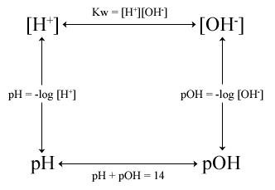

If [H+] = 1E-6, what is [OH-]?

If [H+] = 1E-3, what is the pH? Is it an acid or a base?

If [OH-]= 1E-10, what is the pOH? Is the substance an acid or a base?

If [OH-] = 1E-5, what is the pH? Is it an acid or a base?

If [H+]= 0.0001, what is the pOH? Is it an acid or a base?

If the hydrogen ion concentration is 1E-2, what is the pOH? Is it an acid or a base?

Identify the acid, base, conjugate acid, and conjugate base below:

HBr + H2O 🡪 H3O+ + Br–

NH3 + H2O 🡪 NH4+ + OH–

Acid Base Titration Problem

1. What is the molarity of a hydrochloric acid solution, 30.0 mL of which is just neutralized by 48.0 mL of 0.100 M NaOH?

**Goal 4.02**

In a closed system, energy is neither ________ nor _____________, but can be _____________ from one form to another. This is referred to as the Law of Conservation of Energy.

Define the following:

Endothermic reaction (w/ examples)-

Exothermic reaction (w/ examples)-

Catalyst (and tell how it does what it does)-

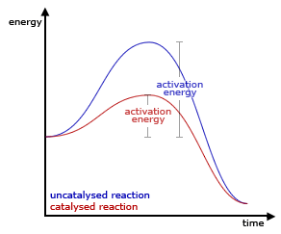Be sure you understand this diagram.

(Effect of catalyst, activation energy, reactant side, product side)

Be sure you could label EXACTLY activation energy.

Is this an exothermic or endothermic reaction?

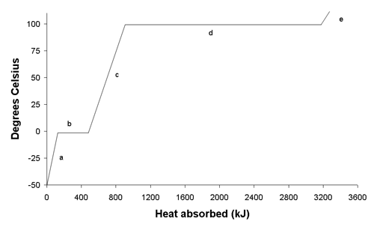Label the relevant parts.

Where is Potential Energy changing?

Where is kinetic energy changing?

What is the freezing point?

What is the melting point?

At what point would some of the material be liquid and some gas?

The above diagram is called a heating curve. Draw and label a cooling curve.

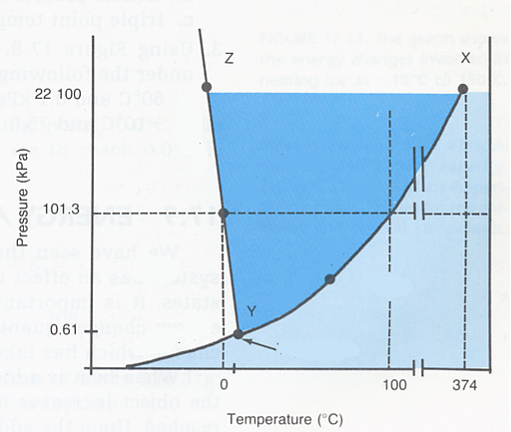

This is called a _____________________

Label the relevant parts.

What substance is this for?

If you move from 50 to -50 at standard pressure what change has occurred?

Moving from 0.5 to 100kPa at 50C what change occurs?

Describe the conditions at point Y.

Describe the conditions at point X?

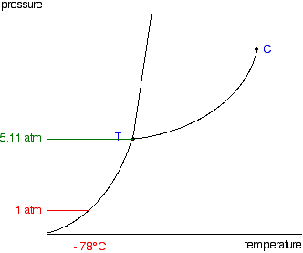

This is a phase diagram for carbon dioxide.

What is interesting about the change in state it undergoes at standard pressure according to the diagram?

At what sort of conditions could you have liquid carbon dioxide? (You may answer qualitatively.)